Access Request Application

## **Purpose**

This application will be used whenever any type of access request is made for our internal computing systems. This includes, new access, modified access and access removal. Any access request must go through an approval process that includes the approval of several stakeholders for each system. These include members of the IT, System Owner and Human resources departments.

This application will help us in to ensure that we are in compliance with university policies regarding internal controls. You can read the policy here:

<http://share.facil.columbia.edu/Policies/CUFO%20Policies%20and%20Procedures/CUFO%20Internal%20Controls%20Policy.pdf>

## **The Process**

When new or modified access is required for one of our internal software applications, a request must be submitted using the Access Request application.

**All access requests will be submitted and approved online at:** [**https://access.cuf.columbia.edu**](https://access.cuf.columbia.edu) **Users will login using their Columbia UNI and password.**

**The following document describes the process of submitting and approving access requests.**

### **Creating a New Request**

Employees cannot request access for themselves. Only a manager can request access for one of their reports. To enter a new request, click the “New Access Request” link at the top of the application. From there, you will be required to enter information about the request and who it’s for.

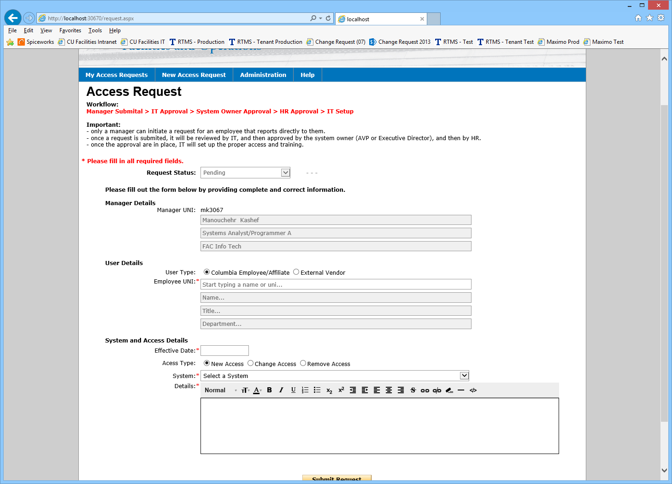

* The person entering the request will have their information will be pre-filled as the requesting manager (based on their log-in).
* Choose if the request is for a current employee/affiliate or for an external vendor. For a current university employee, simply enter the UNI or name, and their information will be located and populated automatically. For external vendors, you must enter their information manually (Name, email, company).
* Provide details on the access needed. Effective date, if the request is for new access, for an access change or for access removal. Select the system and provide any additional details in the comment box provided.
* Submit the request. Once the details are provided, click the submit button to save the request and forward to the appropriate parties. An email with the details, and a link to the request will be sent to the IT department for approval and a copy will be sent to the submitting manager and user the access is requested for.

### **Approval**

Once a new request is submitted, the approval process begins. There are 3 levels of approval that must be completed. An IT department approval, a System Owner approval and finally an approval by the Human Resources department.

IT Approval - The first approval request is sent to the designated IT Approvers for the system that the access is requested for. The IT Approver will:

* Review the request for accuracy and any missing details and obtain clarification if needed
* Enter a System Owner to route the request in the next step
* Approve or Reject the request.

If the IT Approver chooses to approve the request, and email is forwarded to the System Owner, with the full details of the request indicating that their approval is needed. The manager and employee are CCed to the email.

If the request is rejected, the submitting manager, the user and the IT approver will get an email with the details and the status.

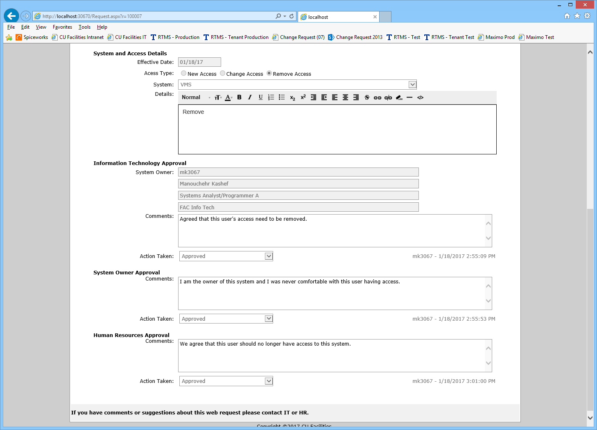

System Owner Approval – Once the IT department approves a request, the system owner receives an email with a link for the request, which they can use to approve or deny the request. Once the System Owner approves the request, an email is forwarded to the Human Resources approver with all the history and details. If the request is denied, the submitting manager, the user and the owner get an email with the details and status. The manager and employee are CCed to the email.



Human Resources Approval – The final approval that is needed is from the Human Resources department. A Human Resources approver is designated for each system using the same administration screen for systems where the IT Approvers are designated. If the request is approved by the Human Resources department, that ends the approval process. The manager and employee are CCed to the email.



Completion – Once a request is approved, the IT department will proceed to modify the users access. Once the access is updated, the IT user responsible for that system will mark the request as by checking the completed box at the top of the Access Request screen.

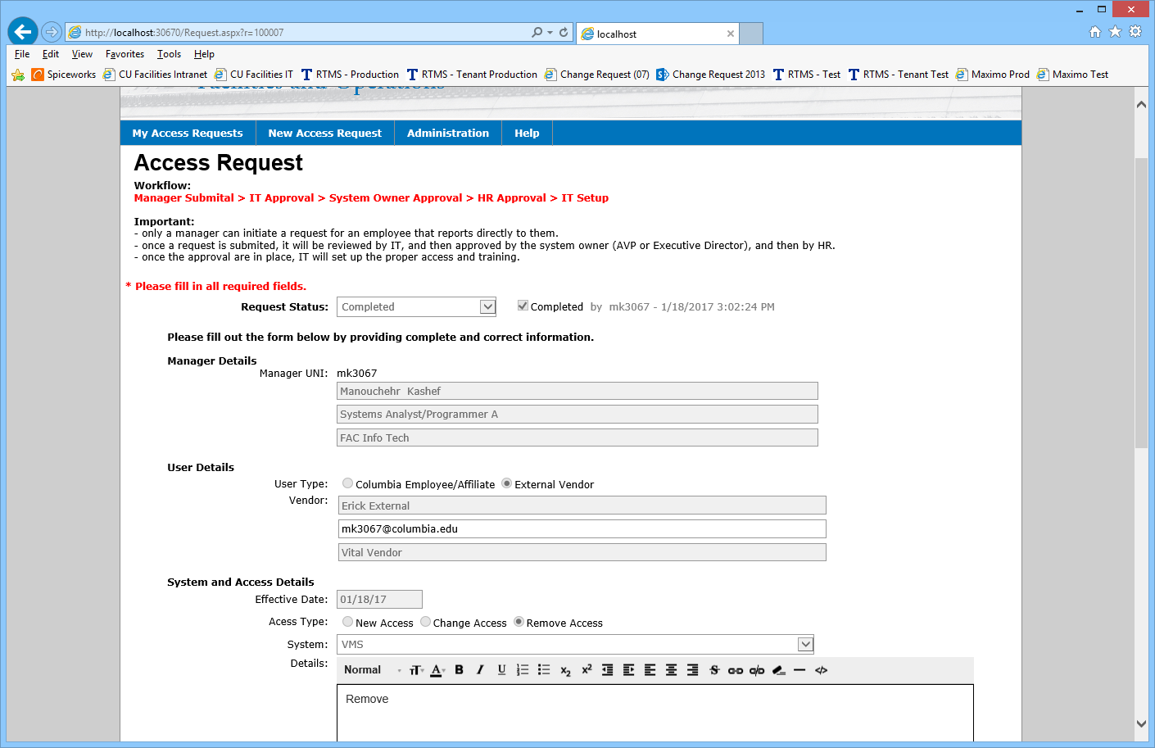

### **Requests History**

To review your requests, past and present, you can go to the “My Access Requests” tab in the application. There you will see a searchable list of all your requests. The list of requests can be filtered by system, status or field/value search.

To view the details of any of the requests in your list, simply click the Request ID link of the request you want to view and you will be taken to the request detail screen.

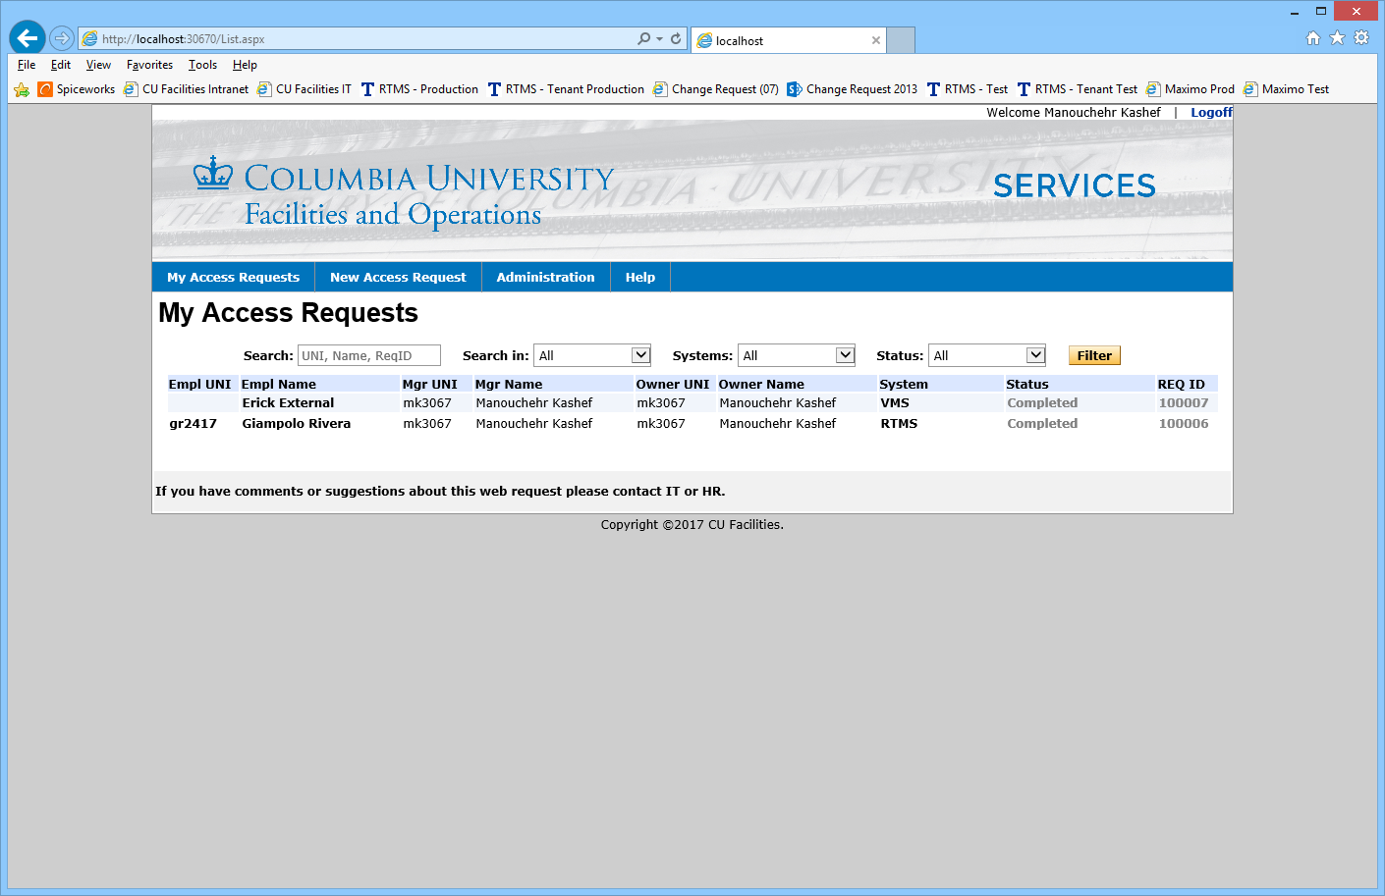

### **User Administration**

Users with administrator level access to the application can add and edit application users. Users can be assigned IT, HR or Admin level access. Users can also be made history.

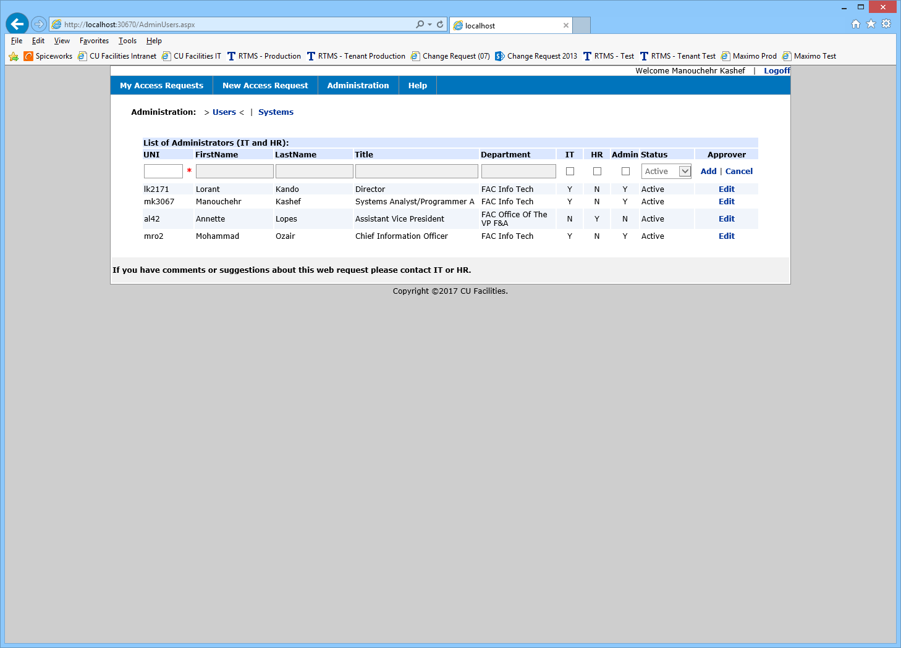

### **System Administration**

The System Templates, IT department and HR department approvers for a system are set up in the Administration section of the application, under the Systems link.

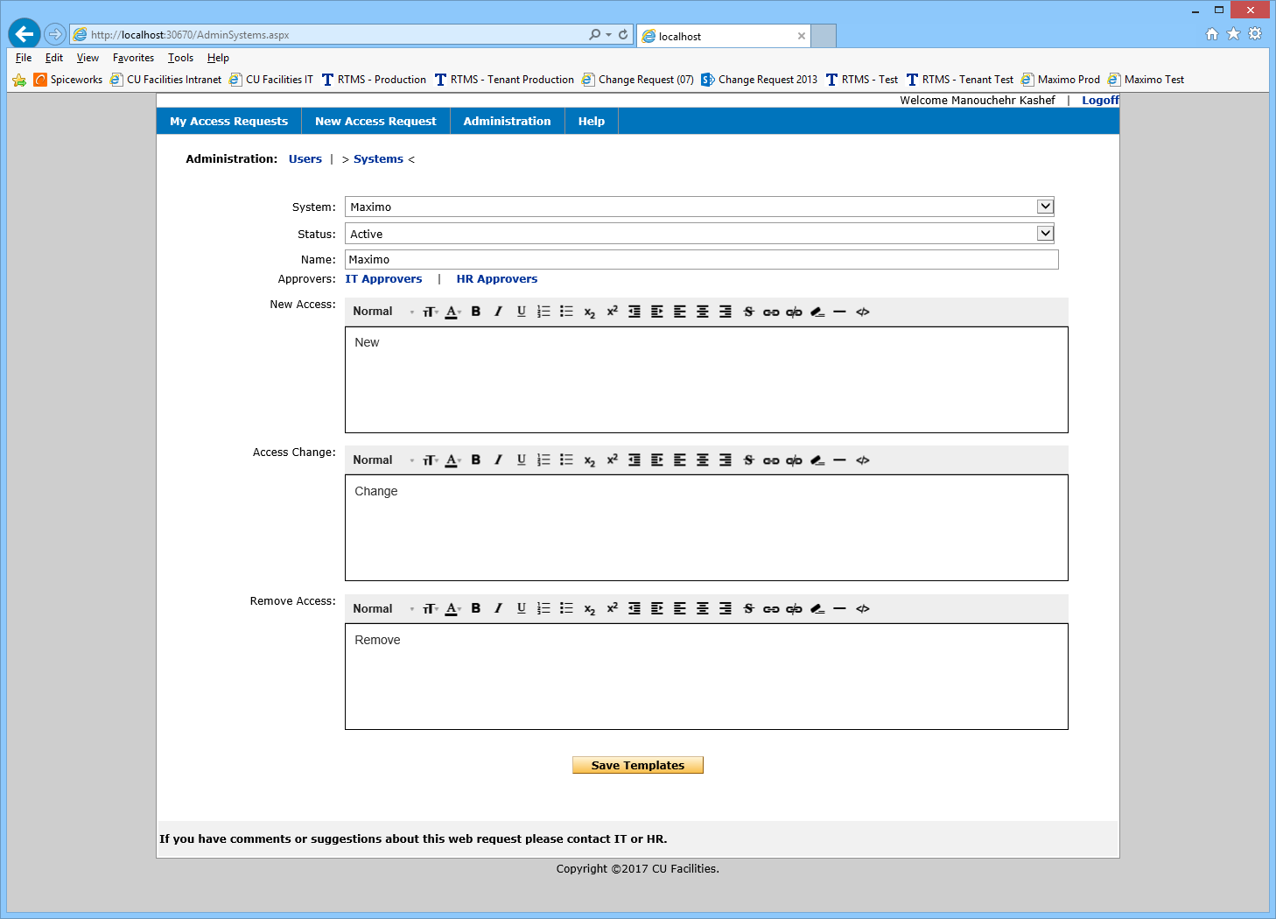

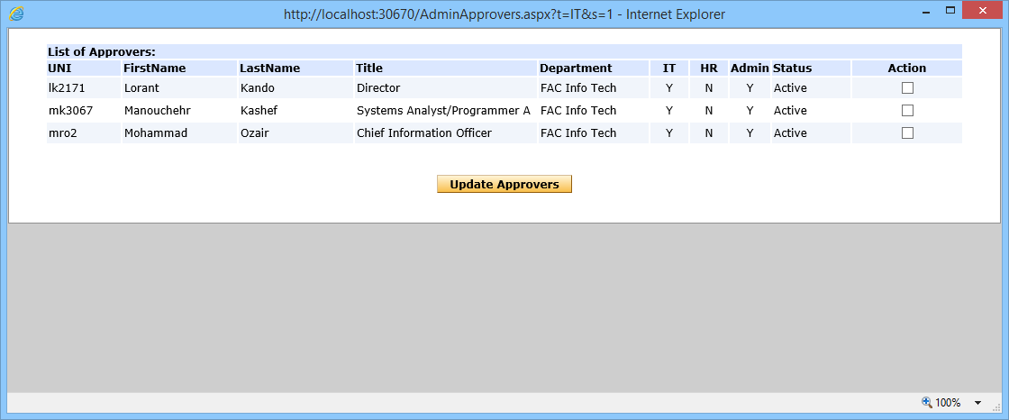

# Access Request Process Flow

